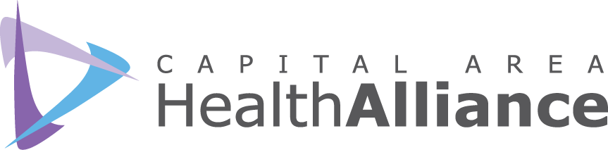

Healthy Lifestyles Committee
June 13, 2018, 9:00-10:30 a.m.
Michigan Osteopathic Association

MINUTES
Participants

Jennifer Arrell, McLaren Health Plan
Ellen Dreps, HGB/AL!VE
Christine Histed, TCOA
Kate Hodgkins, ICMCF
Kathy Hollister, CAHA
Sherri McConnell, CADL
Janine Sinno, ICHD
Brianna Sosebee, CAHA
LaTara Steele, Blue Cross Complete
Casey Thompson, YMCA
Dwight Washington, Clinton County Board of Commissioners
Dana Watson, ICHD
Lisa Wegner, BEDHD

Call to Order and Introductions. Kathy Hollister chaired the meeting and welcomed attendees. Attendees were given the opportunity to introduce themselves.

Partner Updates. Updates were given by representatives from HGB/Al!VE, CADL, BEDHD, TCOA, ICHD and YMCA.

Coping with Pain Brochure. Kathy Hollister provided an update on the Coping with Pain brochure. CAHA, Dr. Narasimha Gundamraj, the Tri-County Office on Aging, and the Public Education Sub-Committee of the Ingham Opioid Abuse Prevention Initiative are collaboratively developing this pain management resource for community members on coping with chronic pain. The brochure will be distributed to employers, physician practices, and community organizations. Sponsorship opportunities are available; sponsoring organizations will be recognized in print and online and will be seen by anyone viewing, picking up, or downloading the brochure. Distribution of the brochure is tentatively scheduled for September.

Cultural Competency. Guest Presenter LaTara Steele, CLAS Coordinator, Blue Cross Complete of Michigan (BCC)
The National Standards for Culturally and Linguistically Appropriate Services (CLAS) in Health Care are issued by the U.S. Department of Health and Human Services Office of Minority Health to advance health equity, improve quality, and eliminate health care disparities by establishing a blueprint for organizations to implement culturally and linguistically appropriate services. CLAS was created in 2000 (enhanced in 2013) and consists of 15 national standards.

BCC addresses CLAS in several ways:
- Language services (telephonic, virtual, face to face)
- Translation of documents
- Collecting Race, Ethnicity & Language (REL) data
- Collecting social determinants of health data
- Provide additional community services and resources (e.g. bill payments, food & clothing pantries)
- Community partnerships and collaborations

- Committees and workgroups (Member Advisory Committee, CLAS Committee, Disparity & Project Committees)

BCC has hosted several CLAS events for its associates. These events provide in-depth understanding of cultural differences amongst BCC’s servicing population and associates. The events include celebrations and presentations featuring Native American Heritage Month, Black History Month, Asian Pacific American Heritage Month, LGBTQ, Samaritas Refugee Resettlement, and Deaf C.A.N (Community Advocacy Network).

Meeting attendees completed an individual Self-Assessment Checklist, identifying areas in which they might improve the quality of their services to culturally diverse populations.

Ingham County Health Department 2018/19 Health Equity & Social Justice Workshop Series. The Health Equity & Social Justice Workshop shines light on racism, classism, genderism, heterosexism and other types of oppression as root causes of health inequities. Participants will learn about and practice tools, conversations and approaches for disrupting oppression and creating more just and equitable workplaces, communities and societies. Application forms are available at http://tinyurl.com/HESJ2018-19.

Next Meeting: July 11, 9:00-10:30 a.m., Michigan Osteopathic Association

