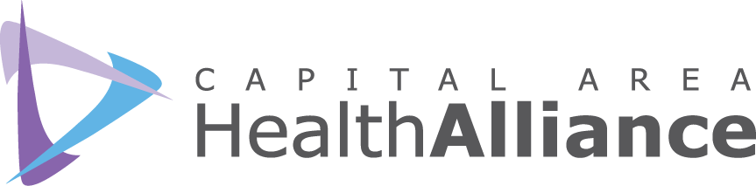

Capital Area Health Alliance - Healthy Lifestyles Committee
May 9, 2018, 9:00-10:30 a.m., Ingham County Health Department

MINUTES
Participants

Jennifer Arrell, McLaren Health Plan
Marvin Cato, COGL
Ellen Dreps, HGB/AL!VE
Surae Eaton, Delta Sigma Theta
Debbie Edokpolo, ICHD
Christine Histed, TCOA
Kate Hodgkins, ICMCF
Kathy Hollister, Capital Area Health Alliance
Ana Hornburg, Michigan Health Council
Larry Leatherwood
Majel Maes, Greater Lansing Food Bank
Karen McCloskey, MDHHS Arthritis Program
Sherri McConnell, CADL
Leslie Polack, Sparrow Health System
Brianna Sosebee, Capital Area Health Alliance
Amy Stoakes, LCC
LaTara Steele, Blue Cross Complete
Jan Urban-Lurain, Spectra Data and Research
Angela Waters Austin, One Love Global
Dana Watson, ICHD

Call to Order and Introductions. Kathy Hollister chaired the meeting and welcomed attendees. Attendees were given the opportunity to introduce themselves.

Health Equity Social Justice Exploration Series Review. Kathy Hollister reviewed the Health Equity & Social Justice Exploration Series that has been taking place over the past six months. The goal of the series is to “Raise awareness of health inequity; identify actions that committee members can take toward implementing health equity practices and policies in their organization; and develop a greater comfort level and common language when speaking about health inequities.”

Racial Equity Assessment/Implicit Bias Screening. Guest Speaker Angela Waters Austin, One Love Global
One Love Global is committed to revitalizing urban centers and creating sustainable communities where justice, peace and opportunity are attainable for all children. Its goal is to break transgenerational cycles of poverty and trauma in the African American community through social entrepreneurship and leadership development. One Love Global is also the lead facilitator for the Truth, Racial Healing & Transformation process in Lansing.

Founded by the W.K. Kellogg Foundation, Truth, Racial Healing & Transformation (TRHT) is a comprehensive, national and community-based process to plan for and bring about transformational and sustainable change, and to address the historic and contemporary effects of racism. The goal of TRHT is to jettison the false belief in a hierarchy of human value and transform policies and systems that were created out of and that continue to uphold this belief.
- Not a program or initiative, but a process
- Engage people across the spectrum
- Healing and creating change in the community
- Truth and recognition of history
- Work towards policy solutions
- Foster new ways of relating as human beings
- Full awareness of our individual and collective strengths, vulnerabilities and resilience
The TRHT Framework consists of five areas: Narrative Change; Racial Healing and Relationship Building; Separation; Law; and Economy.

- Narrative Change: Examining how to create and distribute new complex and complete narratives in entertainment, journalism, digital and social media, school curricula, museums, monuments and parks and in the way we communicate that can influence people’s perspectives, perceptions and behaviors about and towards one another so that we can work more effectively and productively towards community-based change.

- Racial Healing and Relationship Building: Focusing on ways for all of us to heal from the wounds of the past, to build mutually respectful relationships across racial and ethnic lines that honor and value each person’s humanity, and to build trusting intergenerational and diverse community relationships that better reflect our common humanity.
- Beyond Separation: Examining and finding ways to address segregation, colonization and concentrated poverty in neighborhoods to ultimately ensure equitable access to health, education and jobs.

- Decolonization
- Housing
- Health
- Arts & Culture
- Immigration & Migration
- Education & Development

- Law: Reviewing discriminatory civil and criminal laws and the public policies that come from them and recommending solutions that will produce a just application of the law.

- Law Enforcement
- Safety
- Criminal Justice
- Mass Incarceration

- Immigration & Migration
- Education & Development
- Voting Rights & Election

- Economy: Studying structured inequality and barriers to economic opportunities and recommending approaches that can create an equitable society.

- Employment
- Labor
- Workforce
- Wealth
- Immigration & Migration
- Education & Development
- Philanthropy

In June 2017, the Kellogg Foundation committed grant funding in 14 multi-sector collaborations in communities across the United States to implement the TRHT process using this framework. These places include Battle Creek, Kalamazoo, Flint & Lansing, MI; State of Alaska; Baton Rouge & New Orleans, LA; Buffalo, NY; Greater Chicago, IL; Dallas, TX; Los Angeles, CA; Richmond, VA; Selma, AL; and St. Paul, MN.

The local goal is for Metro Lansing to examine the truth of our history and how racial inequities have been perpetuated.

Year One Accomplishments include:

- 5 Transformation Teams
- Regular convenings
- Expanded partnerships
- Robust evaluation
- National Day of Racial Healing: Community Chew & Chat, Lunch & Learn, Commemorative CD

HLC attendees participated in a small group exercise, with each group answering questions about one of the five areas of TRHT framework and its relationship to health equity.

Next Meeting: June 13, 9:00-10:30 a.m., Michigan Osteopathic Association

